Module 6: Configuration Management(Ansible)
- Introduction of SCM and Ansible

Software Configuration Management (SCM)
Git and SCM tools are widely used in software development.
Software Configuration Management (SCM) is the process of tracking, organizing, and controlling changes made to software, documents, source code, and other project resources during the software development life cycle.
SCM helps developers:
- Maintain different versions of software
- Track changes in source code
- Prevent conflicts between team members
- Restore previous versions if errors occur
- Improve collaboration and project management

Objectives of SCM
- Version control of files
- Change management
- Build and release management
- Maintaining software quality
- Team coordination and collaboration

Features of SCM
- Source code management
- Version tracking
- Backup and recovery
- Branching and merging
- Audit and reporting

Popular SCM Tools
- Git
- GitHub
- GitLab
- Subversion
- Mercurial

Introduction to Ansible
Ansible is an open-source automation tool used for configuration management, application deployment, task automation, and orchestration.
It is developed by Red Hat and is mainly used by system administrators and DevOps engineers.

Features of Ansible
- Agentless architecture (no software installation required on client systems)
- Simple YAML-based playbooks
- Easy automation of repetitive tasks
- Secure communication using SSH
- Fast and lightweight

Components of Ansible
- Inventory – List of managed systems/hosts
- Playbook – YAML file containing automation tasks
- Modules – Predefined tasks/functions
- Controller Node – System where Ansible is installed
- Managed Nodes – Target systems managed by Ansible

Advantages of Ansible
- Easy to learn and use
- Reduces manual work
- Improves consistency
- Saves time in server management
- Supports cloud and network automation

Common Uses of Ansible
- Server configuration
- Software installation
- Application deployment
- User management
- Cloud provisioning
- Ansible Ad hoc commands ,playbooks using YAML, push pull model
wsl –install
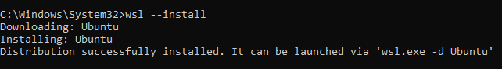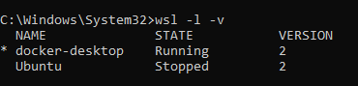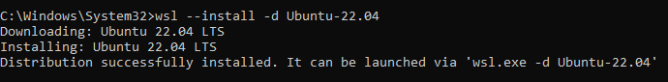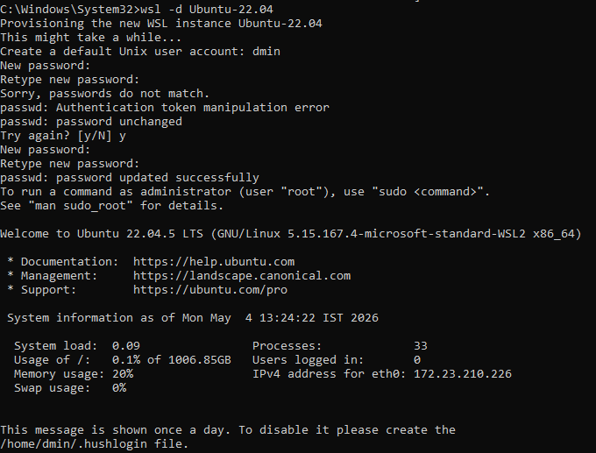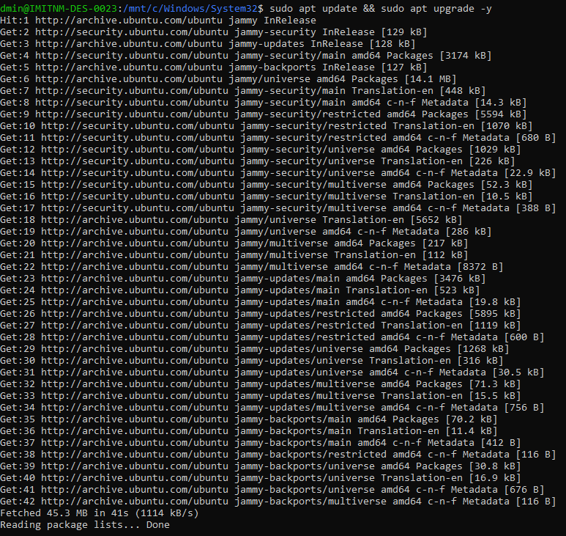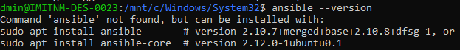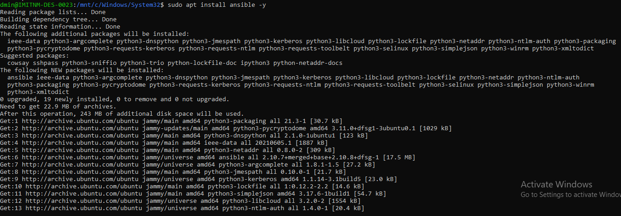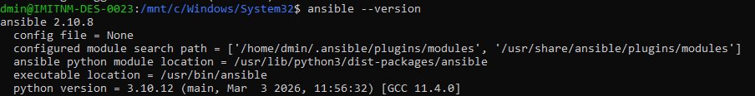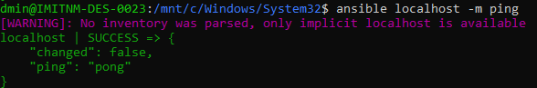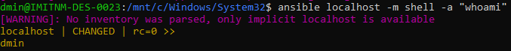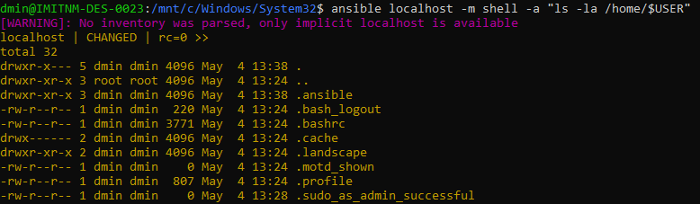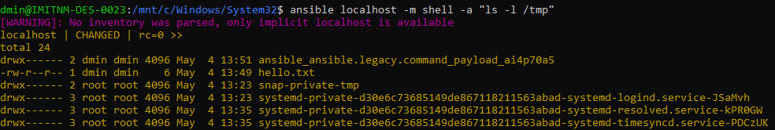
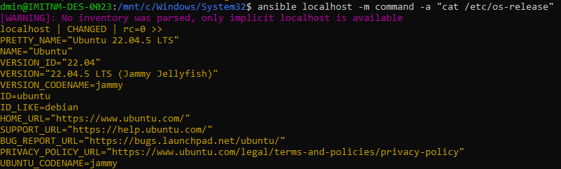
FOR UNINSTALL
ansible local -m apt -a "name=nginx state=absent" -b
